🧠 1. BERT
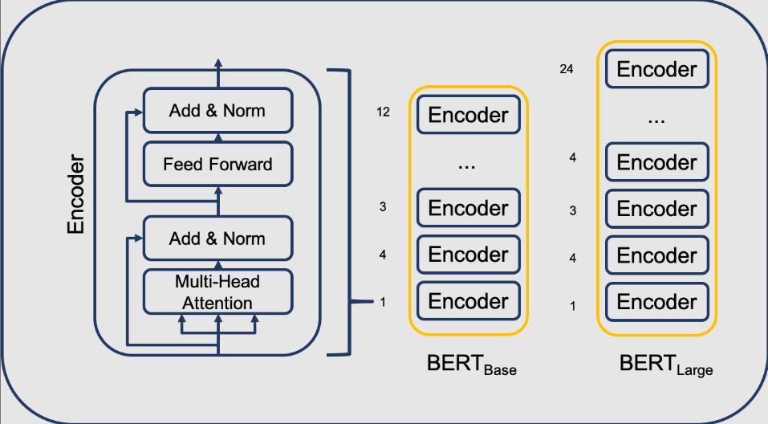
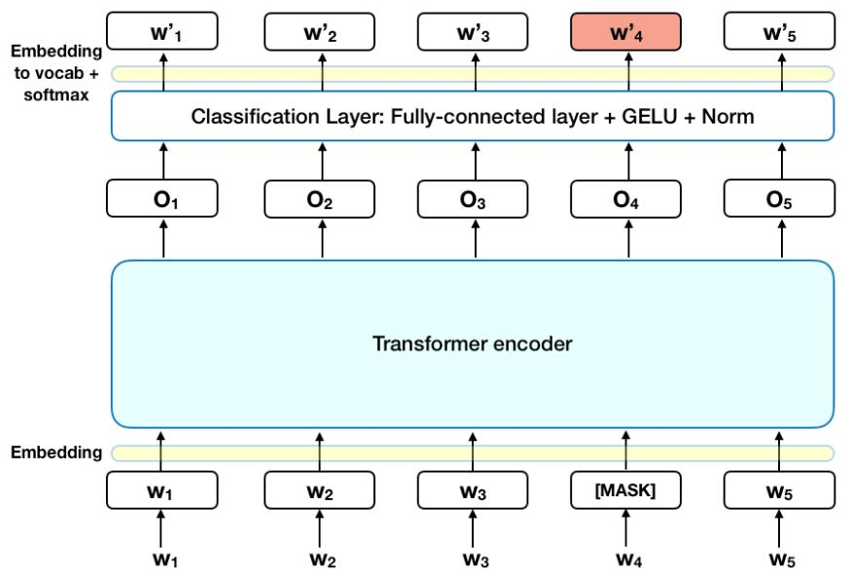
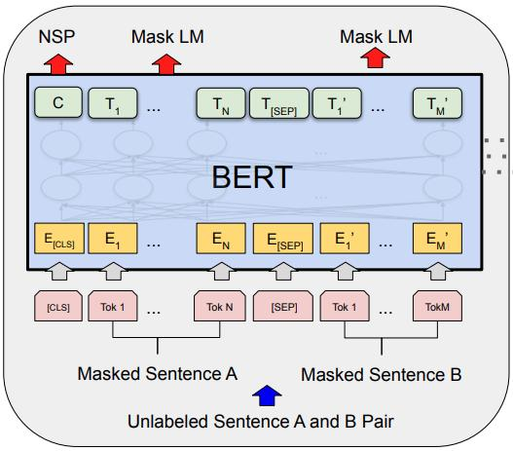
5
BERT is the original breakthrough model from Google that changed NLP.
🔑 Key Ideas:
- Bidirectional understanding → reads text left + right simultaneously
- Trained using:
  - Masked Language Modeling (MLM) (fill in missing words)
  - Next Sentence Prediction (NSP)
- Strong at:
  - Question answering
  - Text classification
  - Named entity recognition
✅ Pros:
- Very powerful and accurate
- General-purpose NLP model
❌ Cons:
- Large and computationally expensive
- Slower for real-time applications

🚀 2. RoBERTa
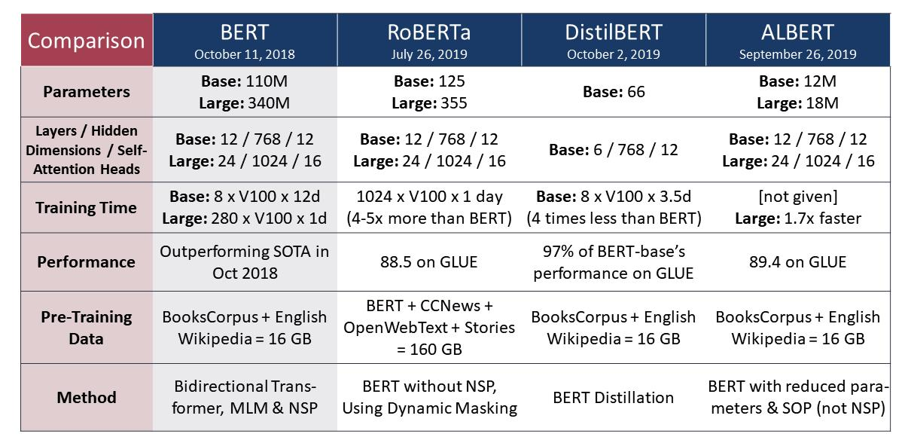
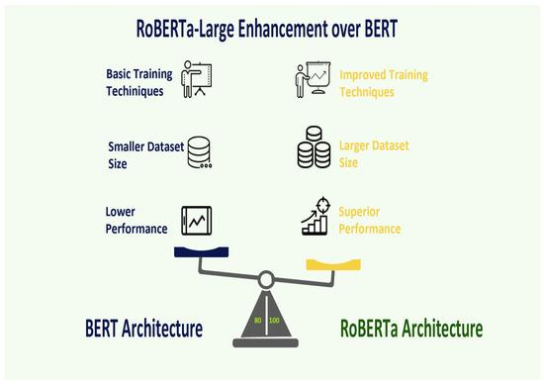
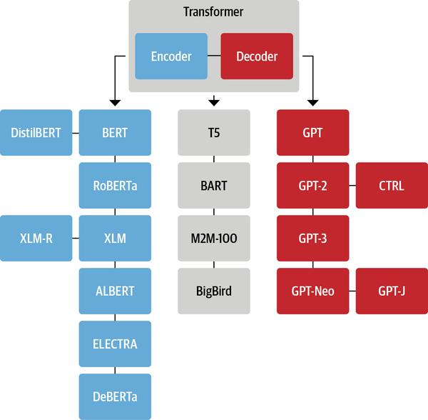
RoBERTa is an improved version of BERT by Facebook (Meta).
🔑 What Changed:
- ❌ Removed Next Sentence Prediction (NSP)
- ✅ Trained on more data
- ✅ Longer training time
- ✅ Dynamic masking (changes masked words every epoch)
✅ Pros:
- Better accuracy than BERT
- More robust training strategy
❌ Cons:
- Even more computationally expensive
- Still large
👉 Think of it as:
“BERT, but trained smarter and longer.”

⚡ 3. DistilBERT

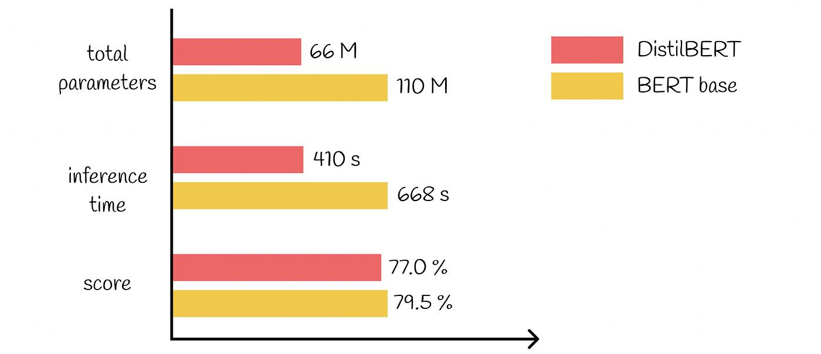
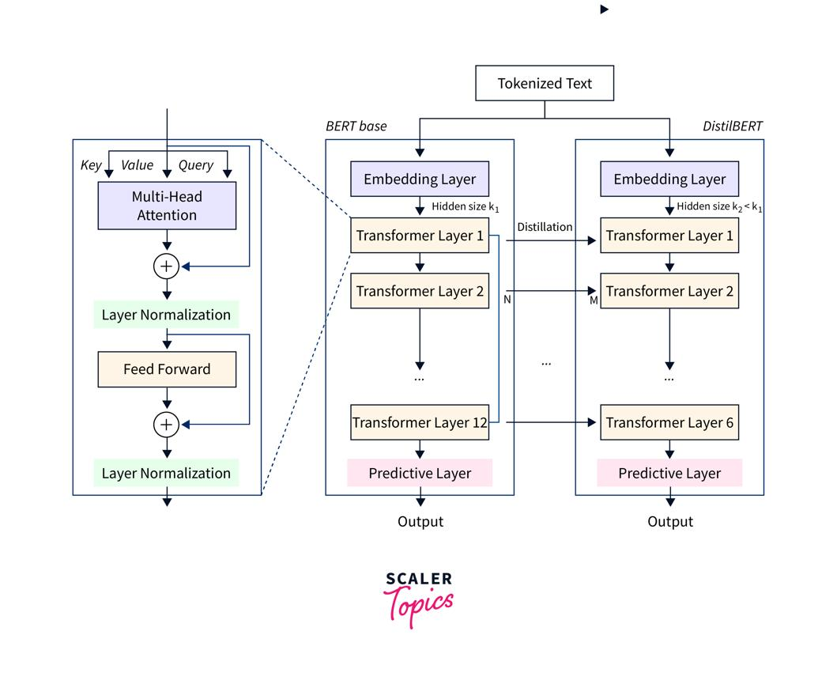

DistilBERT is a smaller, faster version of BERT.
🔑 Key Idea:
- Uses knowledge distillation
→ A smaller “student” model learns from a larger “teacher” (BERT)
📊 Characteristics:
- ~40% smaller
- ~60% faster
- Retains ~95% of BERT performance
✅ Pros:
- Fast and lightweight
- Great for production, mobile, APIs
❌ Cons:
- Slightly less accurate than BERT/RoBERTa

🔥 Side-by-Side Comparison
Feature | BERT | RoBERTa | DistilBERT
Origin | Google | Meta (Facebook) | Hugging Face
Size | Large | Larger | Smaller
Speed | Medium | Slower | Fast
Accuracy | High | Higher | Slightly lower
NSP Task | Yes | No | No
Use Case | General NLP | High-performance NLP | Fast/efficient NLP

🧩 Simple Analogy
- BERT → A smart student
- RoBERTa → Same student, but studied longer + better strategy
- DistilBERT → A faster student who learned from the smart one

🧠 When to Use What?
- Use BERT → if you want a solid baseline
- Use RoBERTa → if you want best accuracy
- Use DistilBERT → if you need speed + efficiency (APIs, real-time apps)

